**School of Technology**

**Department of Information and Communication Technology Engineering**



**4th Semester (2018-2019)**

**Computer Networks Lab Report**

**Name: - Kalgee Anand Kotak**

**Roll no: - 17BIT016**

**INDEX**

|  |  |
| --- | --- |
| **Sr. No.** | **Experiment** |
| 1. | Exp 1: To terminate a CAT5E cable (Forward Through & Crossover Connection) |
| 2. | Exp 2: Pinging Between Two Different Networks. (3 hosts: one of which has two NIC Cards) |
| 3. | Exp 3: TO SETUP A DHCP SERVER AND CLIENT IN UBUNTU. |
| 4. | Exp 4: Socket Programming -TCP |
| 5. | Exp 5: Socket Programming – UDP |
| 6. | Tool 1: Wireshark |
| 7. | Tool 2: Cisco Packet Tracer |
| 8. | Exp 6: Implementation of Stop and Wait Protocol |
| 9. | Exp 7: Implementation of CRC |
| 10. | Exp 8: Implementation of Checksum |

**EXPERIMENT:1**

**AIM:** TO TERMINATE A CAT5E CABLE

**MATERIAL REQUIRED:**

1. CAT 5E/CAT 6 Cable 2. RJ45 Connectors (8P8C connector)

3. Crimping Tool 4. Network Tester

**PROCEDURE:**

1. Pull about 1 foot of wire from the spool, add about 4 Inches for the plug on each end.
2. Measure out 2 inches from one end of the wire and place the wire in the cable strippers at that location. The cable should be snug in the strippers, but not tight. The second notch inward is appropriate.
3. Ensure the blade of the wire stripper is perpendicular to the wire and turn the wire stripper around the cable once, which will score the sheathing of the wire. (The goal is to only remove the outer sheath and not damage the inner delicate cables)
4. Remove the cable stripper and gently bend the cable along the score line. This should break the sheathing which can be pulled off the wire and thrown away. When removing the sheathing you should expose 8 twisted cables.
5. Separate the individual cables so they are no longer twisted together.
6. Now arrange the Cable in the following configuration.
7. T-568A Configuration

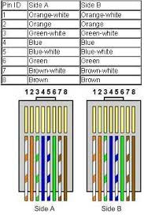

1. Firmly grasp all the cables near the sheathing and slide your fingers up, collecting all the cables into a flat line. Make sure the cables from left to right are the same configuration as described above.
2. Straighten the cables. Do not worry if the cables aren’t an even length, just straighten them as best you can.
3. Using the cable cutters, trim the tips of the cables so they are even. Make sure the cut is perpendicular to the cables.
4. Insert the cables in the connector as shown in the images above. The tab on the connector should be facing the floor White-Orange (for T – 568B configuration) cable should be the furthest left in the connector. When inserted, the sheathing should be just inside the end of the data plug. If the wires are too long, remove the data plug, cut a very small length of wire from the end, and reinsert the cable into the data plug.
5. Looking into the connector check all the cables are as far forward as they can be making sure they are past the metal spikes which will come down when crimped.
6. Insert the prepared plug in the crimping tool and squeeze the handle, crimping the wires.
7. Repeat the process for the other end.
8. Now it is time to test your lead, all testers are different but on my one the lights, light up on after the other and they all worked fine.
9. Repeat the same experiment for TIA 568B Configuration.

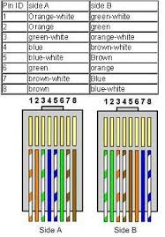

**EXPERIMENT:2**

**AIM: Pinging Between Two Different Networks.(3 hosts: one of which has two NIC Cards)**

* **Steps To Follow:**

1. a. On the Host2 which has two NIC Cards create two Ethernet Connections which lie in different Classes (from A,B,C) as shown below:

**Connection1**

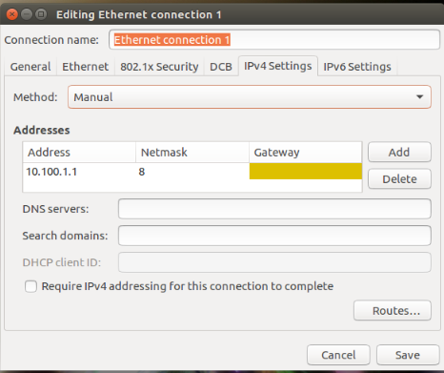

**Connection 2**

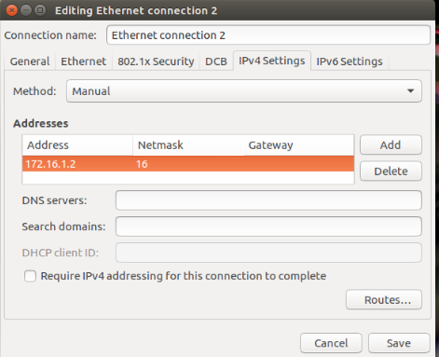

1. a. On the two other Hosts(1 and 3) which have one NIC Card create one Ethernet Connection on each host that is of one of the Classes used in the previous step as shown below:

**Host1Connection**

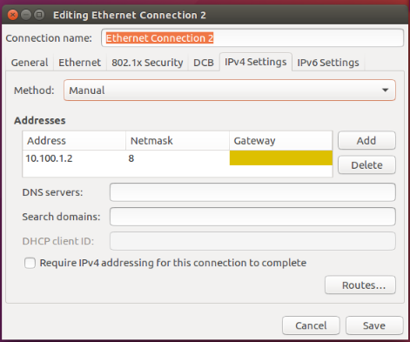

**Host3Connection**

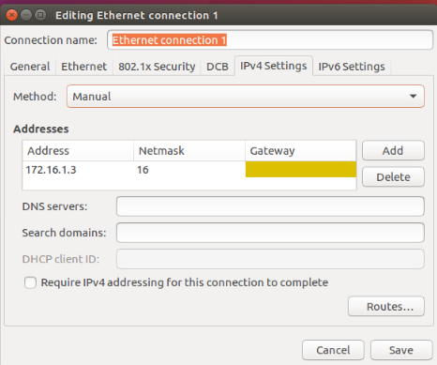

1. Once this is done we can ping from Hoat1(10.100.0.2) to Host2(10.100.0.1 and Vice-versa and we can also ping from Host3(176.16.1.3) to Host2(176.16.1.2) and vice-versa as shown below:
2. **Pinging from 10.100.0.2 to 10.100.0.1**
3. **Pinging from 176.16.1.3 to 176.16.1.2**

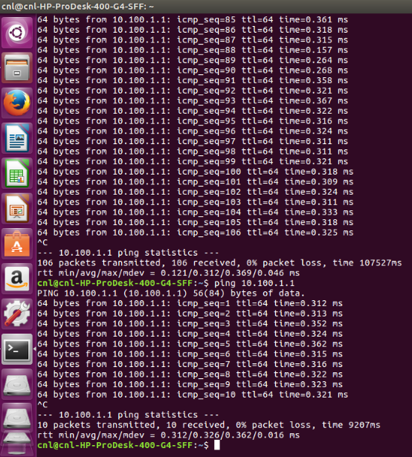**(a)**

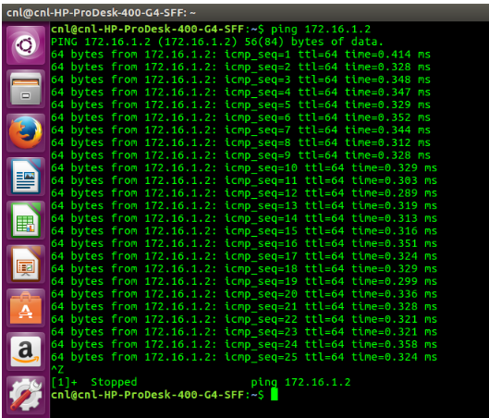**(b)  
Note**: We still won’t be able to ping from **10.100.0.2 to 176.16.1.3** and from **176.16.1.3 to 10.100.0.1.** So, to achieve this we will use the concept of Default GateWay.

1. Assign Default GateWay to Host1 and Host3 according to class in which they lie as shown below:

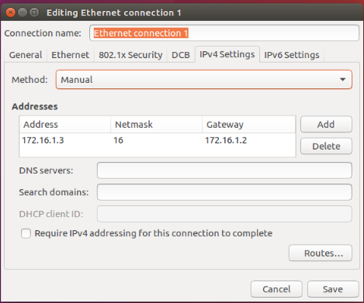

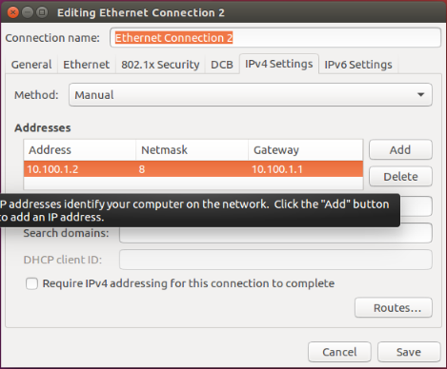

1. Once, the Default Gateway is assigned we will be able to ping from **10.100.0.2 to 176.16.1.3** and from **176.16.1.3 to 10.100.0.1.**
2. Now, in order to ping from Host1 to Host3 the concept of IP Forwarding comes into picture, we have to make **ip_forward** property of Host2 from 0 to 1 ,to do so use the following command:

**sudo gedit /etc/sysctl.conf**

1. An editable file will open, make the change as shown below then save the file and close it.

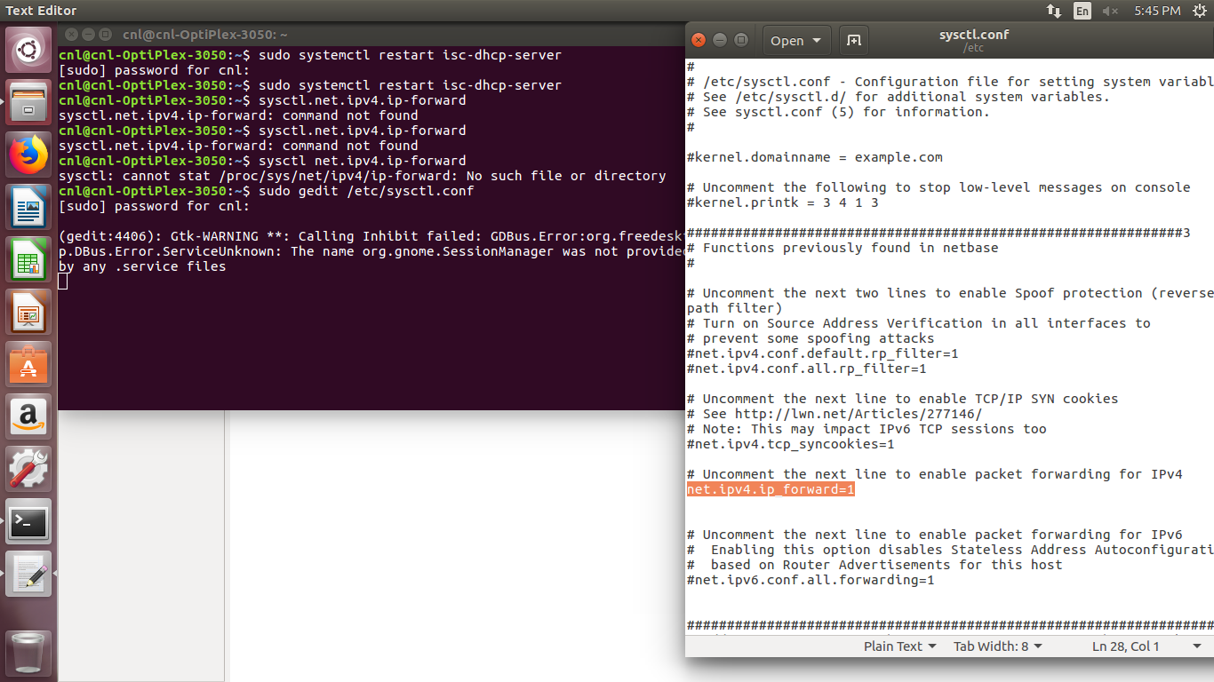

1. Now, after enabling IP Forwarding we can now Ping from Host1(10.100.0.1) to Host3(176.16.1.2)

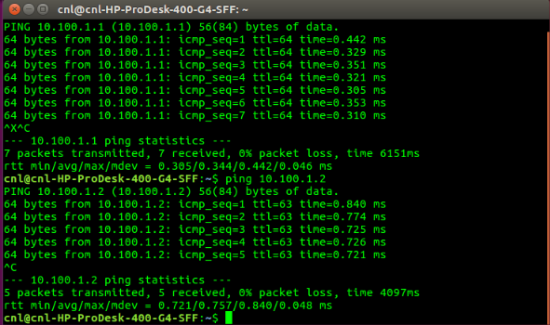

1. This is how we can communicate between two hosts in two different networks.

**EXPERIMENT:3**

**AIM: TO SETUP A DHCP SERVER AND CLIENT IN UBUNTU.**

DHCP, abbreviation of Dynamic Host Control Protocol, is a network protocol that assigns IP addresses automatically to client systems in the network. This reduces the tedious task of manually assigning IP addresses in a large network that has hundreds of systems. We can define the IP range (Scopes) in the DHCP server and distribute them across the network. The client systems in the network will automatically get the IP address.

* **Steps To Follow:**

1. **Install DHCP Server in Ubuntu 16.04 LTS:**

a. Open Terminal (Ctrl + Alt +T) and run the following command to install DHCP server

sudo apt-get install isc-dhcp-server

1. **Configure DHCP server:**
   1. The default configuration file of DHCP server is /etc/default/isc-dhcp-server. We need to edit and modify it as per our requirements.
   2. If you have more than one Network interface card in your DHCP server, you need to mention on which interface should the DHCP server serve DHCP requests.
   3. Use the “ifconfig” command to get the interface name of your network card. It is the address on the first column.

d. To do so, edit /etc/default/isc-dhcp-server configuration file:

sudonano/etc/default/isc-dhcp-server

e. Assign the network interface:

INTERFACES="enp0s3"

1. Then edit the dhcpd.conf file:

sudonano/etc/dhcp/dhcpd.conf

Modify it as shown below.

[...]

* option definitions common to all supported networks...

option domain-name "pdpu.lan";

option domain-name-servers ubuntuserver.pdpu.lan;

[...]

1. To make this server as official DHCP for your clients, find and uncomment the following line that says “authoritative;”
2. Scroll down a little bit , and define the subnet, IP range, domain and domain name servers like below.

[...]

* A slightly different configuration for an internal subnet.

subnet 192.168.1.0 netmask 255.255.255.0 { range 192.168.1.20 192.168.1.30;

option domain-name-servers ubuntuserver.pdpu.lan;

option domain-name "pdpu.lan";

option routers 192.168.1.1;

option broadcast-address 192.168.1.255; default-lease-time 600; max-lease-time 7200;

}

[...]

You can change the subnet and the IP range as per your requirement

1. Now, restart dhcp service:

sudosystemctl restart isc-dhcp-server

1. **Configure DHCP Clients:**
   1. Open Network Connections either from Unity dash or Menu.
   2. In the Network connections window, select your Ethernet card and click Edit.

s

* 1. Click IPv4 Settings and select “Automatic (DHCP)” option. Finally click Save.
  2. Now, restart your client system, and check the IP address of your client system.

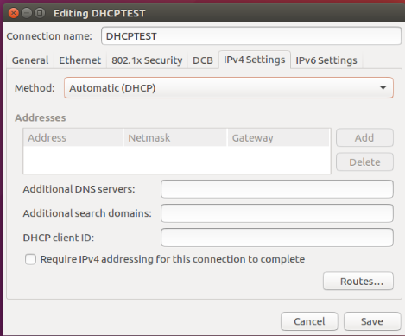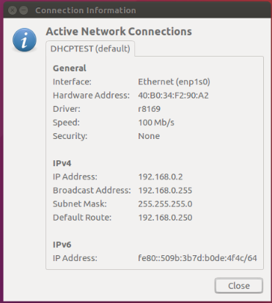

**EXPERIMENT: 4**

**AIM:** Socket Programming -TCP

The **Transmission Control Protocol (TCP)** is one of the main [protocols](https://en.wikipedia.org/wiki/Communications_protocol) of the [Internet protocol suite](https://en.wikipedia.org/wiki/Internet_protocol_suite). It originated in the initial network implementation in which it complemented the [Internet Protocol](https://en.wikipedia.org/wiki/Internet_Protocol) (IP). Therefore, the entire suite is commonly referred to as *TCP/IP*. TCP provides [reliable](https://en.wikipedia.org/wiki/Reliability_(computer_networking)), ordered, and [error-checked](https://en.wikipedia.org/wiki/Error_detection_and_correction) delivery of a stream of [octets](https://en.wikipedia.org/wiki/Octet_(computing)) (bytes) between applications running on hosts communicating via an IP network. Major internet applications such as the [World Wide Web](https://en.wikipedia.org/wiki/World_Wide_Web), [email](https://en.wikipedia.org/wiki/Email), [remote administration](https://en.wikipedia.org/wiki/Remote_administration), and [file transfer](https://en.wikipedia.org/wiki/File_transfer) rely on TCP.

**PROCEDURE:**

* **Server Program**

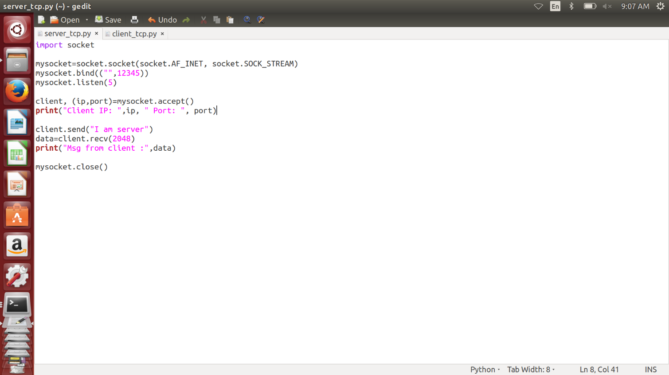

* **Client Program**

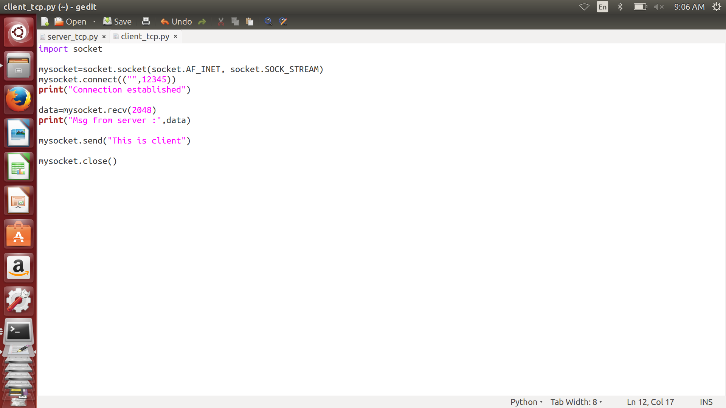

* **Interaction between Server and Client**

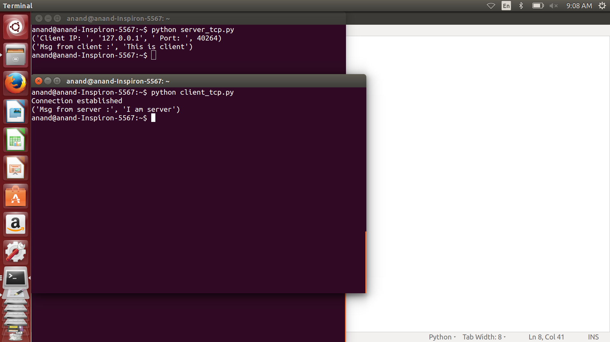

**EXPERIMENT: 5**

**AIM:** Socket Programming -UDP

The **User Datagram Protocol (UDP)** is one of the core members of the [Internet protocol suite](https://en.wikipedia.org/wiki/Internet_protocol_suite). With UDP, computer applications can send messages, in this case referred to as [*datagrams*](https://en.wikipedia.org/wiki/Datagram), to other hosts on an [Internet Protocol](https://en.wikipedia.org/wiki/Internet_Protocol) (IP) network. Prior communications are not required in order to set up [communication channels](https://en.wikipedia.org/wiki/Communication_channel) or data paths. UDP is suitable for purposes where error checking and correction are either not necessary or are performed in the application; UDP avoids the overhead of such processing in the [protocol stack](https://en.wikipedia.org/wiki/Protocol_stack). Time-sensitive applications often use UDP because dropping packets is preferable to waiting for packets delayed due to [retransmission](https://en.wikipedia.org/wiki/Retransmission_(data_networks)), which may not be an option in a [real-time system](https://en.wikipedia.org/wiki/Real-time_system).

**PROCEDURE:**

* **Server Program**

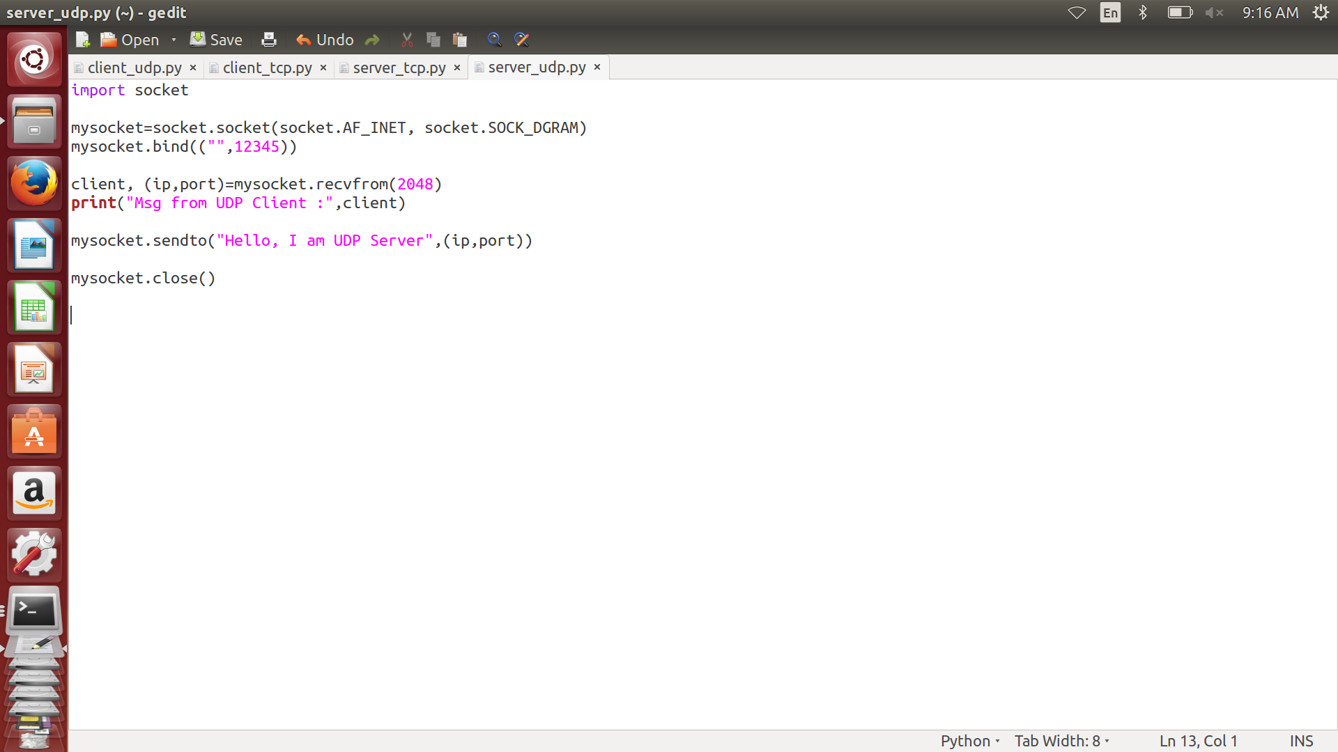

* **Client Program**

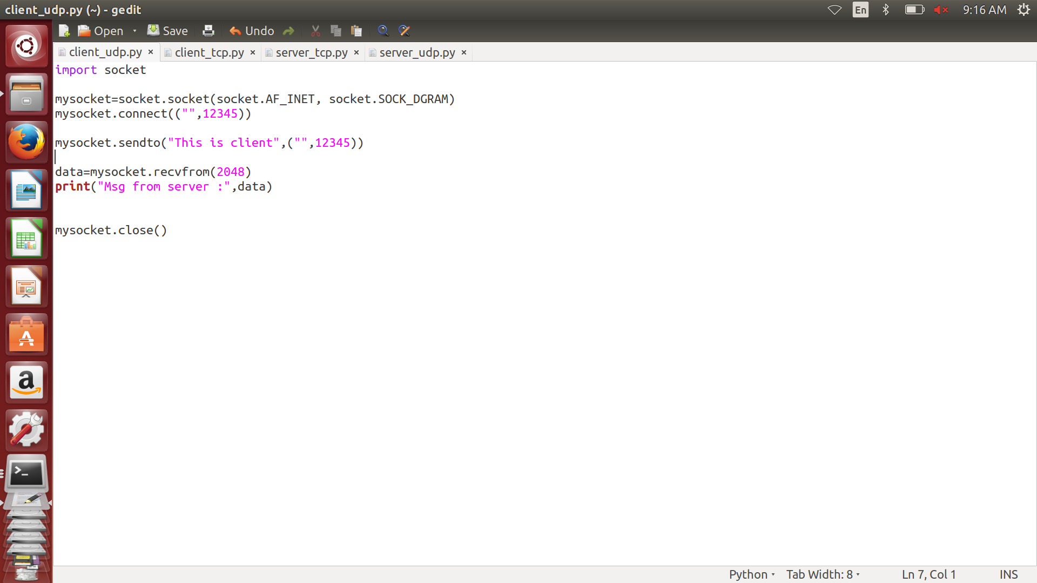

* **Interaction between Server and Client**

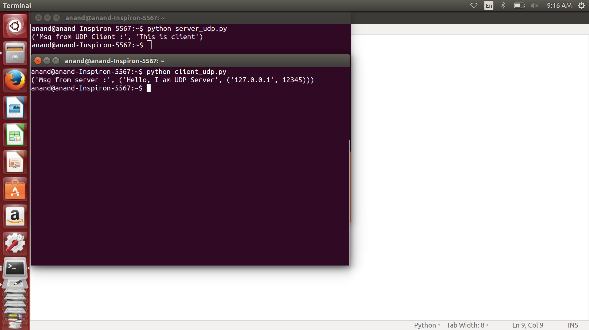

**TOOL 1:**

**Wireshark**

**AIM: To install and setup Wireshark and observe network traffic.**

**About Wireshark:** Wireshark is a free and open-source packet analyzer. It is used for network troubleshooting, analysis, software and communications protocol development, and education.

**Procedure:**

-> Update the ubuntu repositories using the command:

sudo apt-get update

-> Install the wireshark package by running the command:

    sudo apt install wireshark

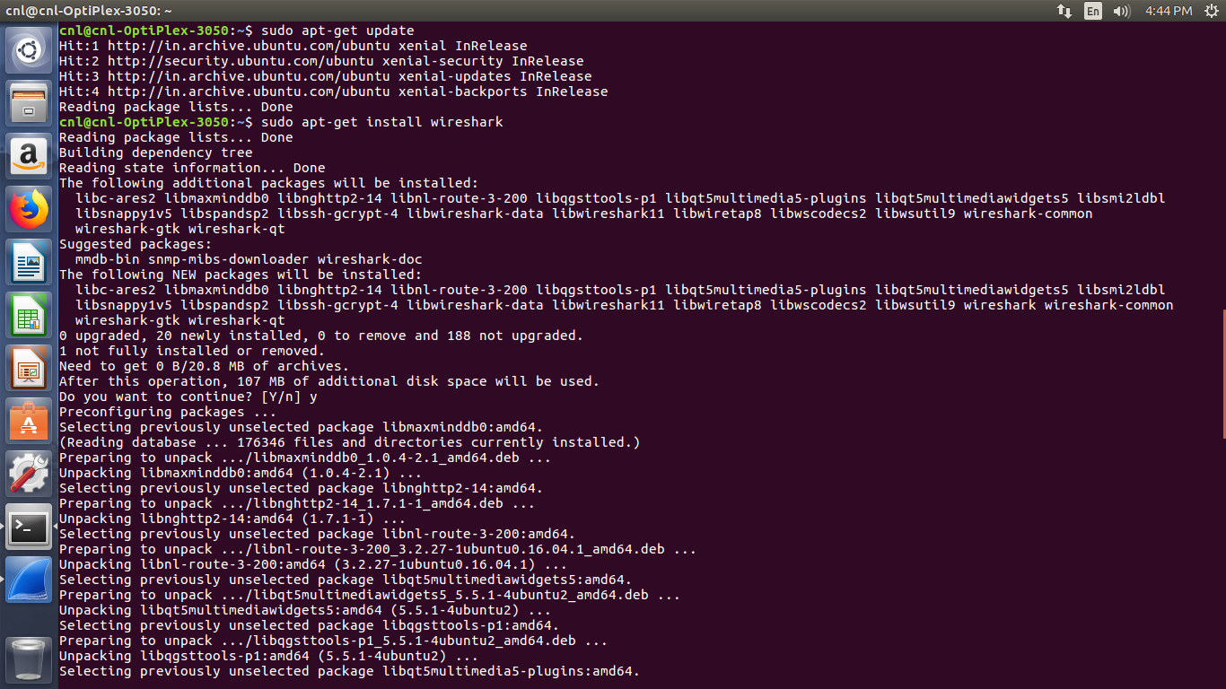

-> Run wireshark and start capturing network traffic for the connection you are using.

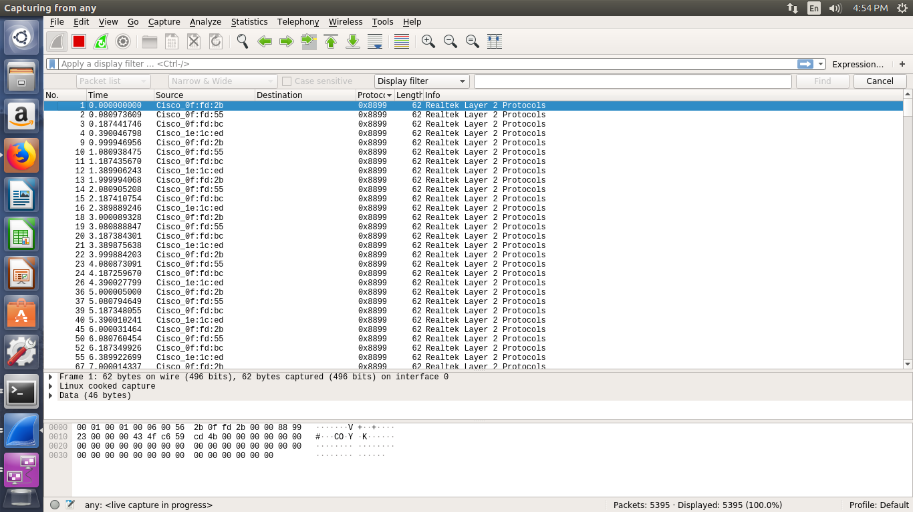

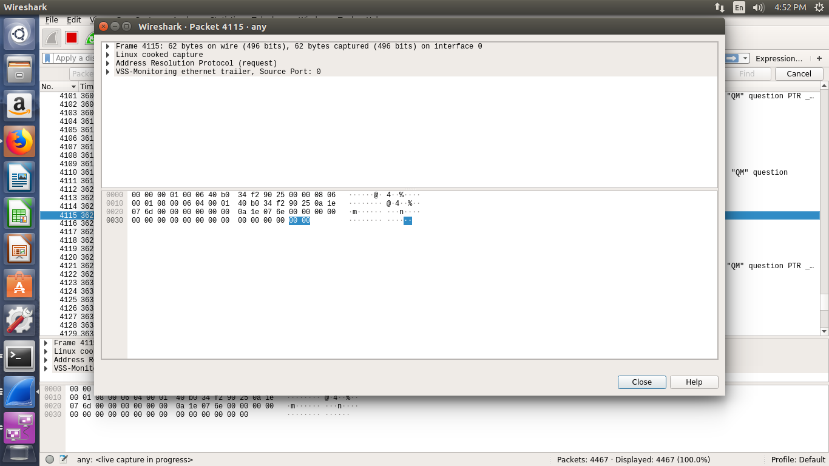-> In the picture below we can observe the source and destination ports as well as ack sequence.

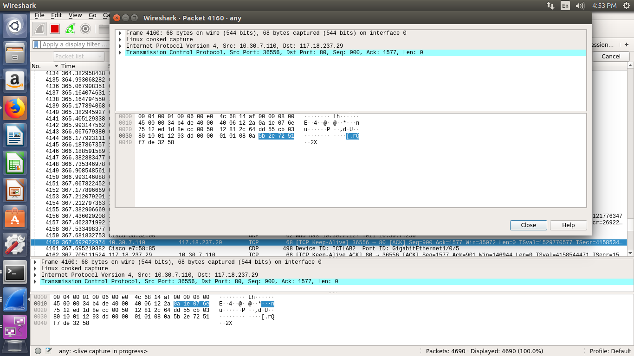

-> This is an example of a multicast packet capture.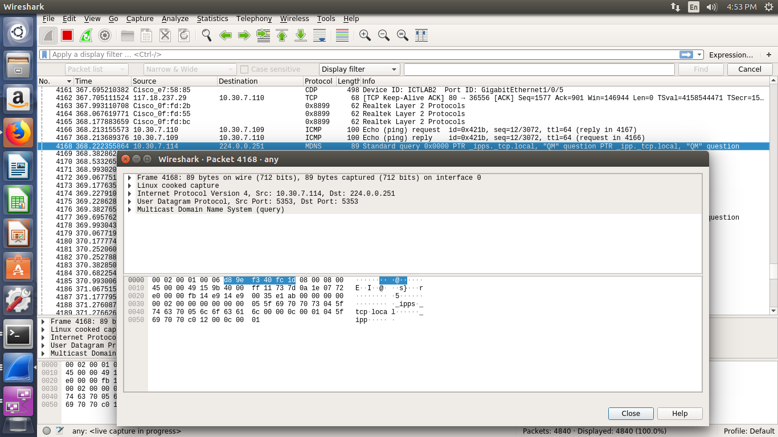

-> Here we observe an https connection and the protocol used to provide a secure connection: SSL (Secure Socket Layer). 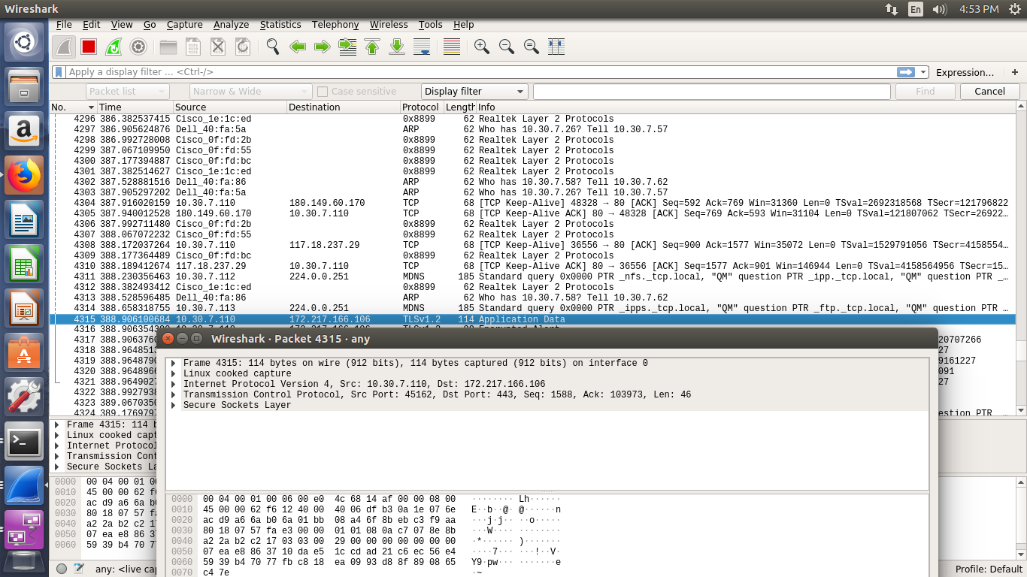

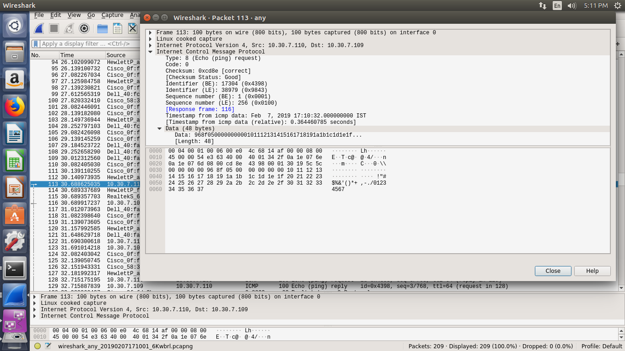

-> Capturing UDP packages: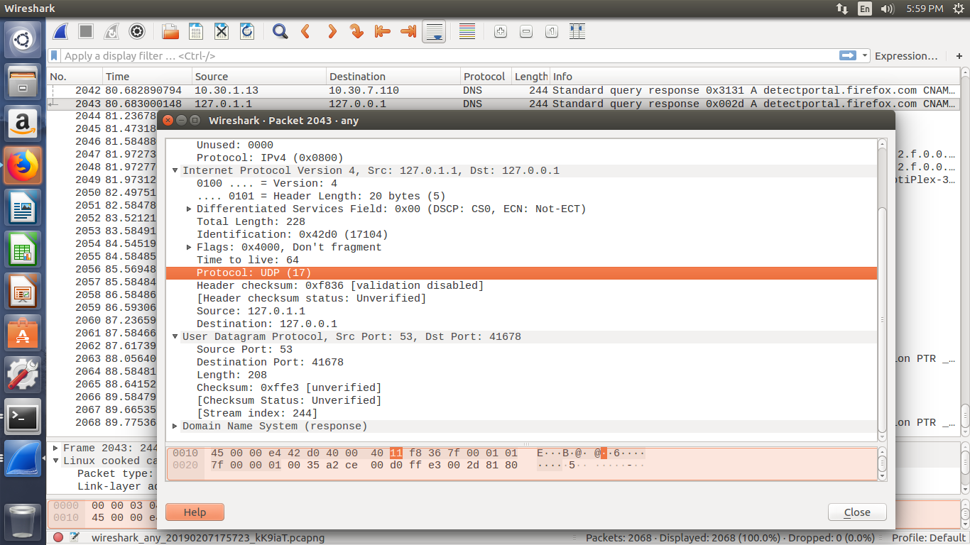-> The images below show TCP and TLS packet captures.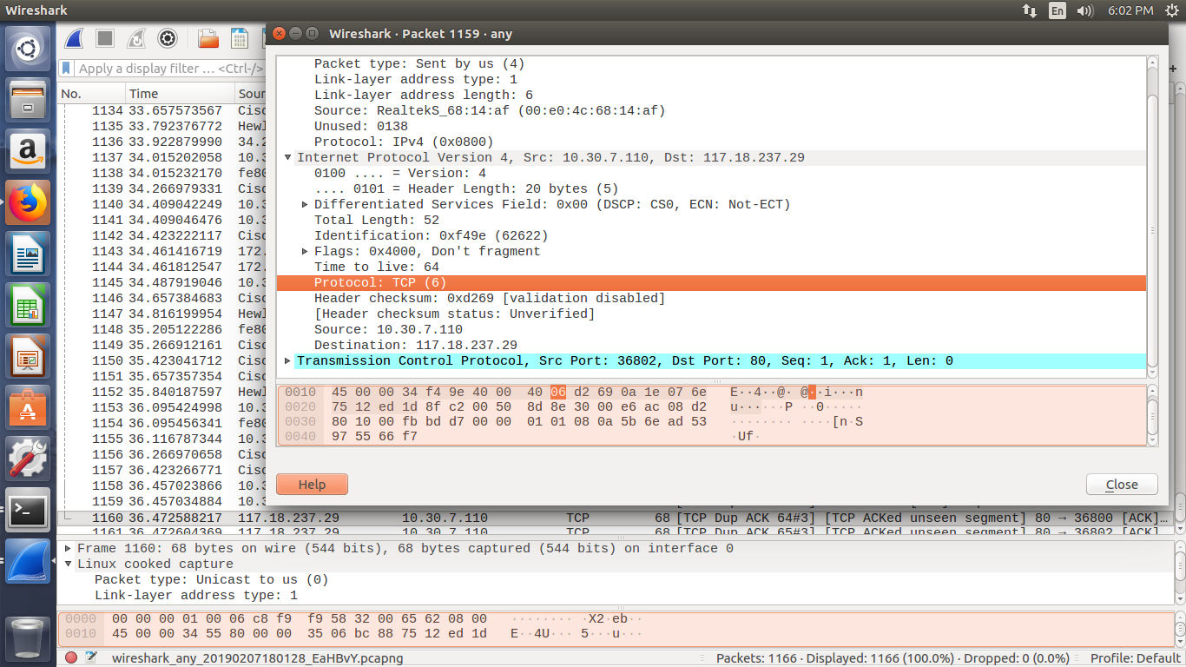

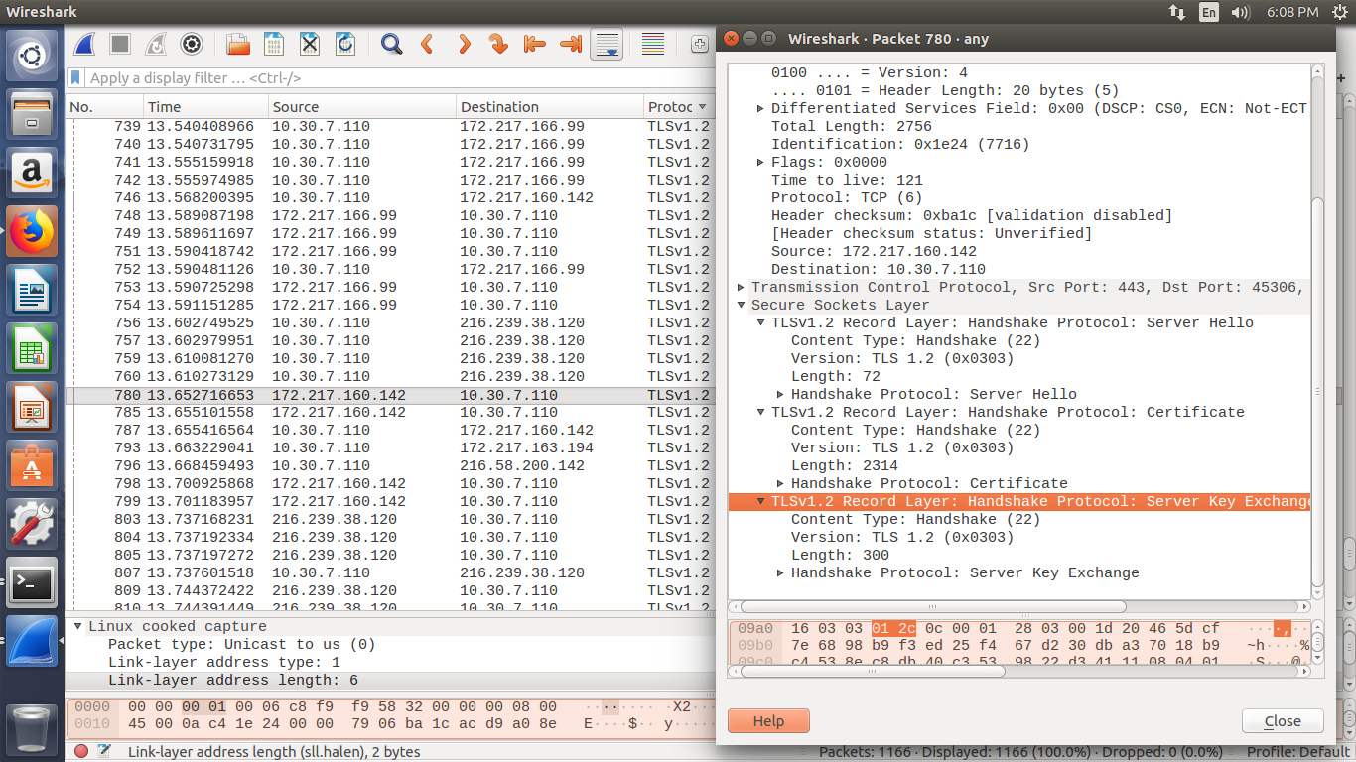

**TOOL 2:**

**CISCO PACKET TRACER**

**AIM:** TO INSTALL CISCO PACKET TRACER AND SIMULATE ONE NETWORK

**THEORY:**

Cisco developed Packet Tracer to help Networking Academy students achieve the most optimal learning

experience while gaining practical networking technology skills. Packet Tracer is a powerful network

simulation platform inspiring student to experiment with network behaviour and ask 'what if' questions.

It supplements physical equipment in the classroom by allowing students to create a network with an

almost unlimited number of devices, encouraging practice, discovery and troubleshooting. About

Networking Academy: Started in 1997, Cisco Networking Academy is an IT & Networking skills and

career building program for learning institutions and individuals worldwide.

**PROCEDURE:**

a. Install DHCP Server in Ubuntu 16.04 LTS: a. Open Terminal (Ctrl + Alt +T) and run the following command in the same directory as

you downloaded the cisco packet tracer file.

tar –zxfvPacketTracer7.tar.gz

b. Now some output will appear, then change file directory (cd) as follows:

cd PacketTracer70

c. The needed file is install. So now type the command

sudo bash install

d. Now some output will appear, then change file directory (cd) as follows

cd PacketTracer70

e. Then type the password and press Enter and select the default location for installation.

f. We need to set up the packet tracer environment parameters so use the following command to run the script.

sudo bash set_ptenv.sh

To run the packet tracer open a terminal and use the following the command: packettracer

g. Simulating a network: a. Use the appliances and tools available at the bottom of the screen to create a network

**NETWORK 1:**

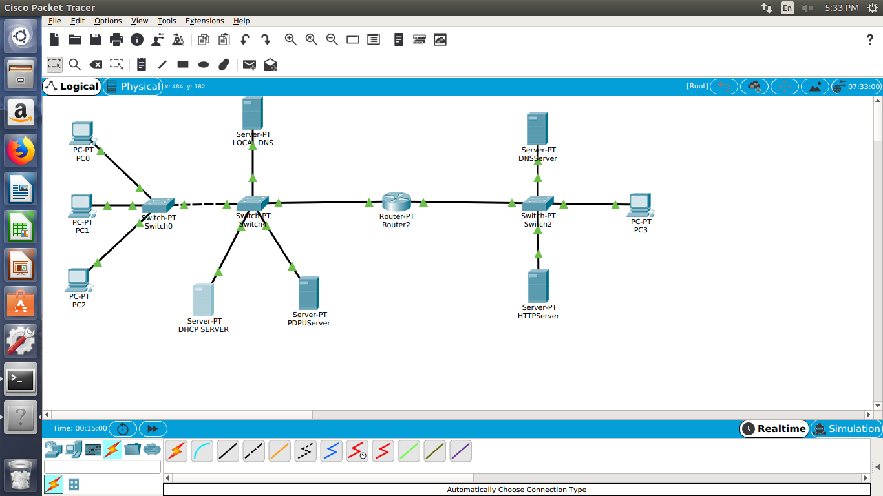

This network consists of 3 end devices (PC’s) connected with a switch which is connected with another switch with 3 servers – DHCP sever, local DNS server, PDPU server. This part of the circuit makes one network. This network is connected to another network with a router in between. The second network consists of another switch connected to 2 servers – DNS server and HTTP server and an end device – PC.

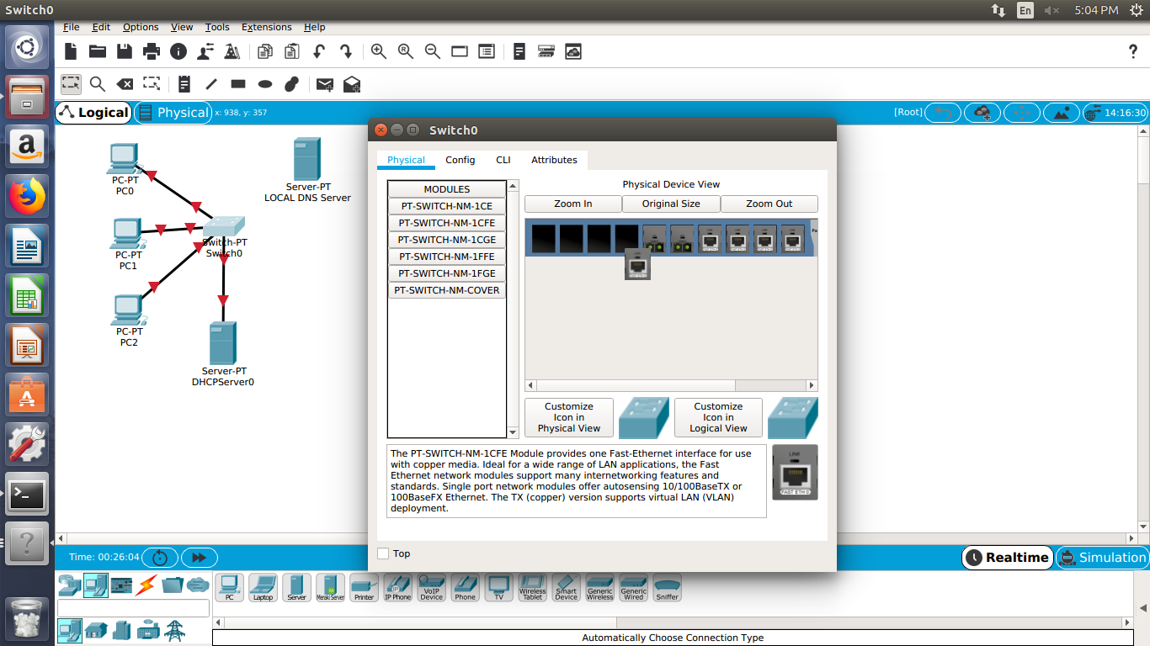

Switch consists of 4 ports (that means it can be connected to 4 other devices). We can edit this feature by going in the physical setting of the switch. Steps:

1. select the physical option in switch settings
2. turn off the switch
3. add the kind of extra port that is required from the menu displayed below
4. turn on the switch to make more connections.

**Setup the Servers in the following configuration:**

**i. SERVER**

1. DNS Server

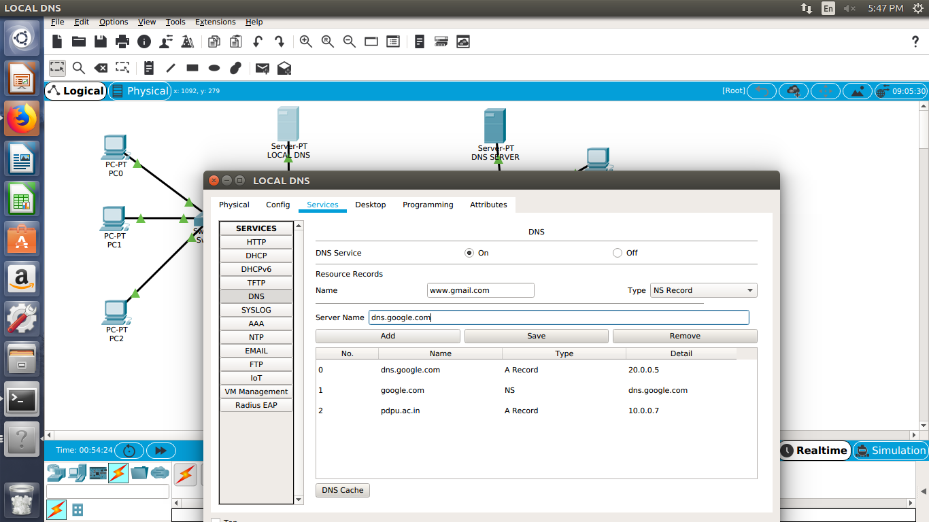

1. Select the Local DNS from the network then select the services menu. From the menu on the left select ‘DNS’ option. In this page edit the fields as required.
2. Turn on the DNS services. Add resource records – name and type.
3. Example – nso.google.com(name) , A Record (type) , 20.0.0.5 (details)

google.com(name) , NS(type) , nso.google.com (details)

pdpu.ac.in(name) , A record (type) , 10.0.0.7 (details)

1. Add it and save it.

2. Static IP

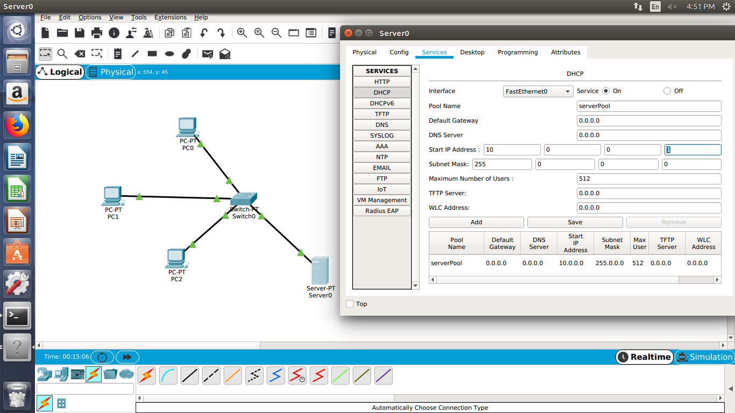

The DHCP server is set according to the following steps:

1. Select the DHCP sever and open the services settings.
2. Select ‘DHCP’ from the menu on the left.
3. Set the services to ‘on’ and fill in the fields. Give a default gateway and fill in the static IP address of the DNS server. Give the start IP Address.
4. Add it and save it.

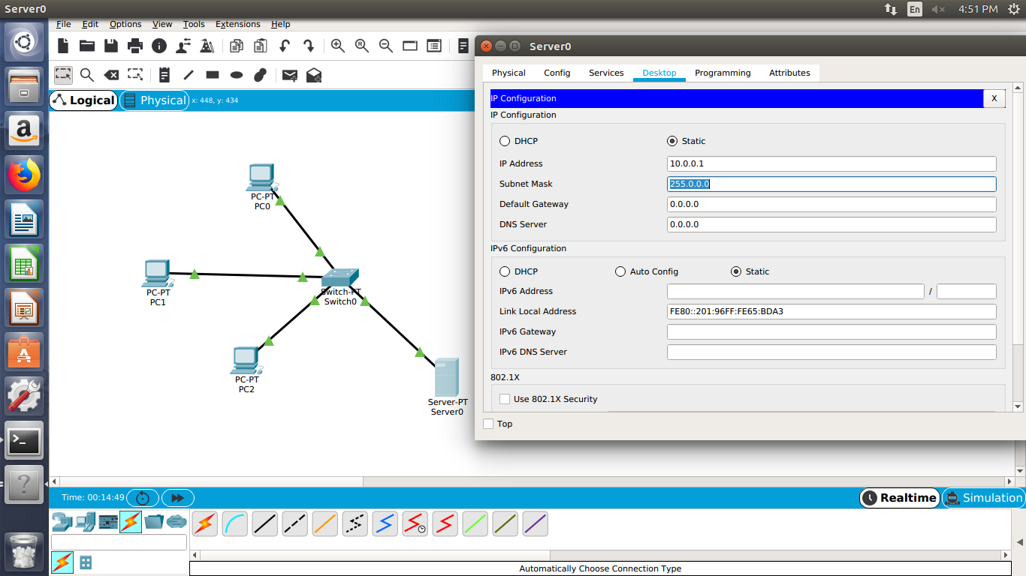

1. In the same menu on the top now choose Desktop and select ‘IP Configuration’.
2. Set the IP Configuration to static.
3. Give the DHCP server an IP Address (example – 10.0.0.1).
4. Set the default Gateway and fill in the IP of the DNS Server.

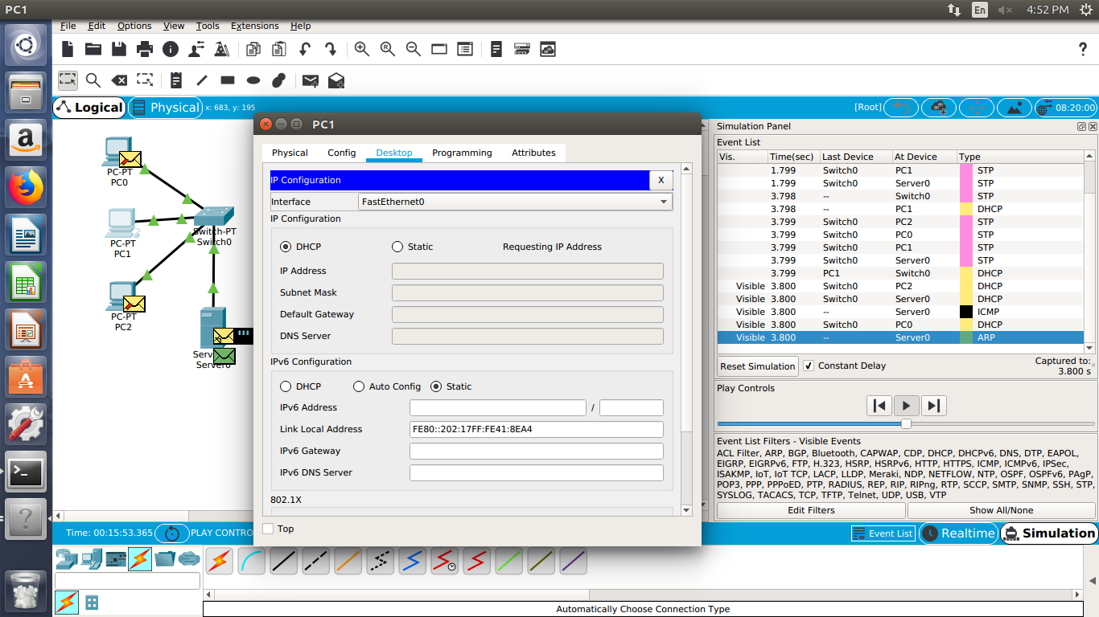

1. Now choose any PC (example PC1 in our circuit) and open the settings.
2. Select Desktop from the top menu and then select ‘IP Configuration’.
3. Set this to ‘DHCP’.
4. Start the simulation an observer the packets flowing as the PC requests the DHCP server for an IP Address.

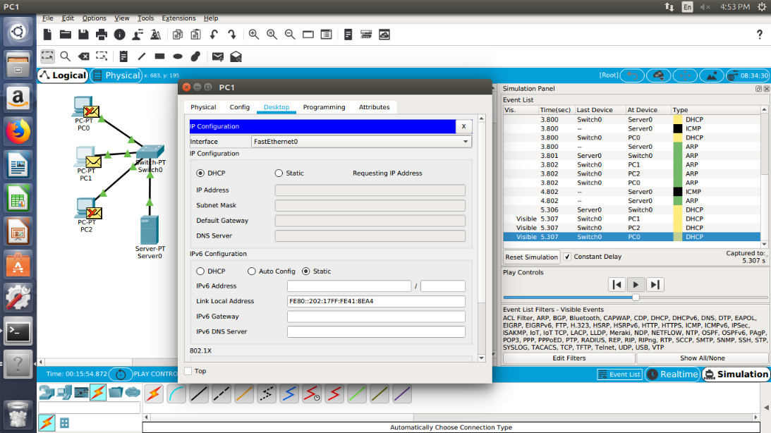

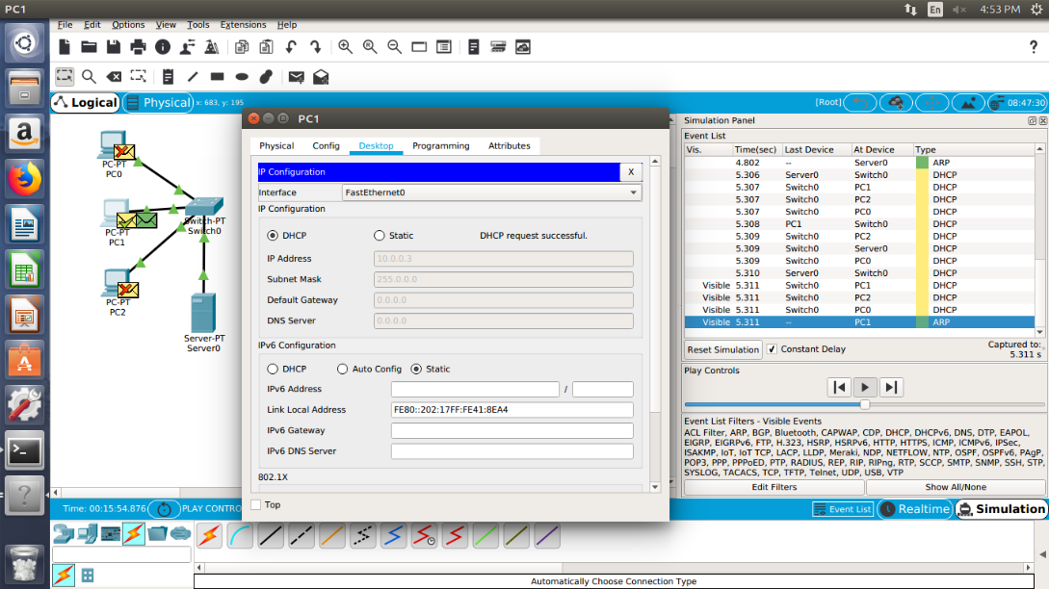

1. The PC will get its IP Address and other details automatically if the DHCP request was successful.
2. Similarly get the IP address for the other PC from the DHCP server. The IP Address will be in a continuous manner.

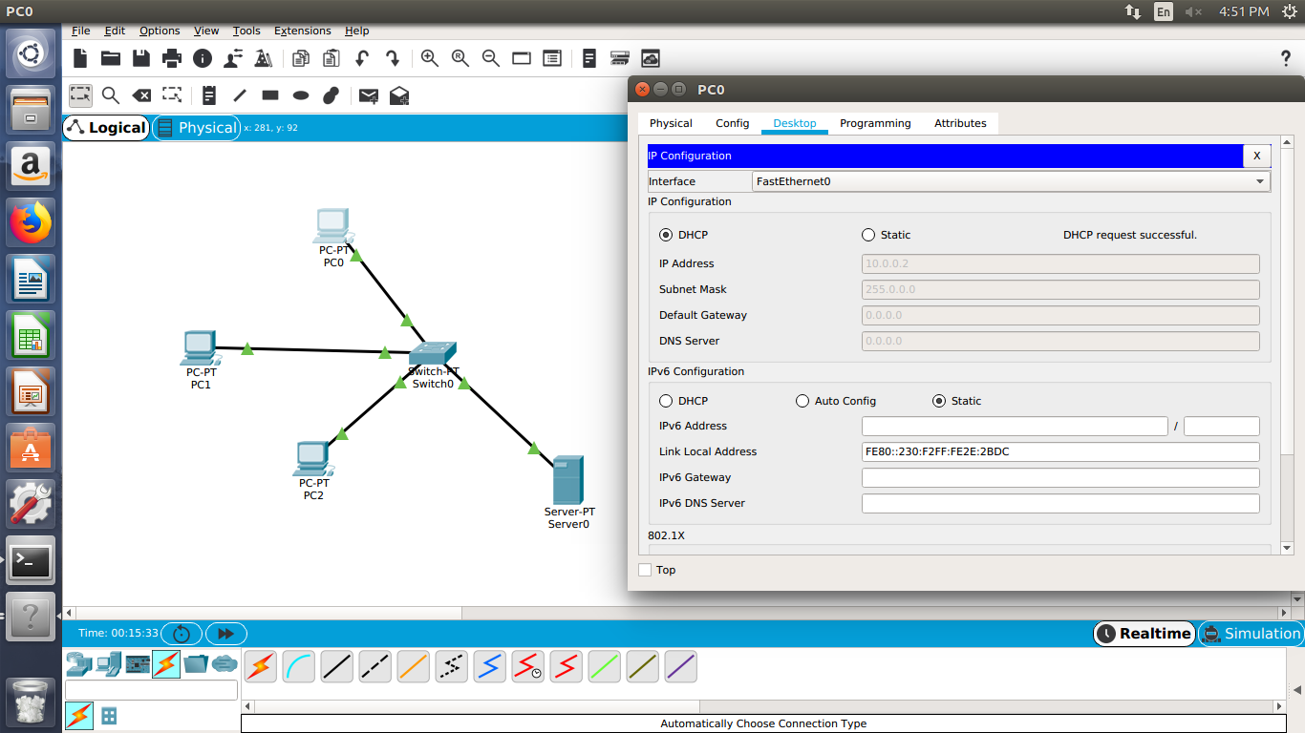

**NETWORK 2:**

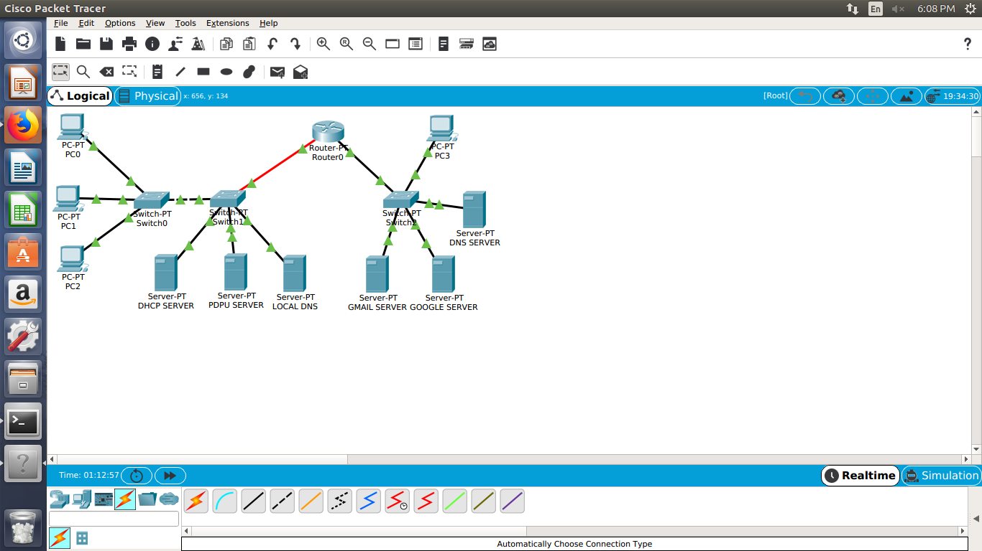

In the second network we have connected 3 end devices (PC’s) with a switch which is connected with another switch connected with 3 servers – DHCP server , local DNS server and PDPU server. This circuit builds up a network which is connected with another network with a router in the middle. The router is connected to a switch which is connected to 3 other servers – GMAIL server, GOOGLE server and DNS server and it is also connected with another PC (end device).

**Server 2: 1. HTTP Server**

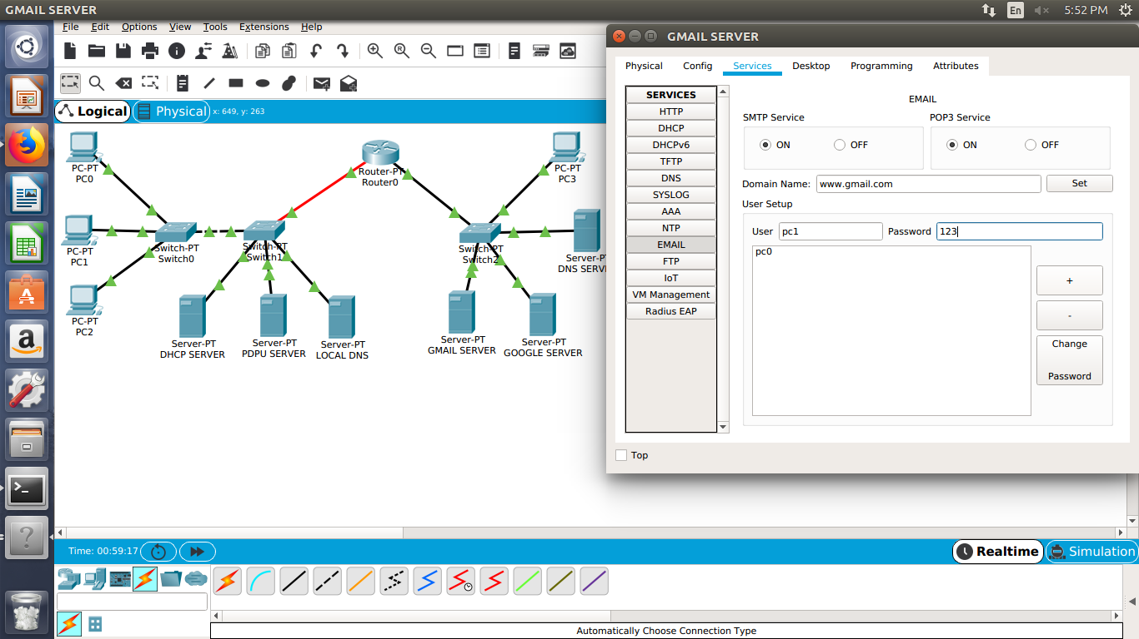

To set up the HTTP server:

1. Choose the settings and go in the services menu on the top. Select ‘EMAIL’ from the left side menu.
2. Fill in all the fields here and set the SMTP services and the POP3 services ‘on’.



Set up the local DNS server like we did in network 1. (follow the same steps)

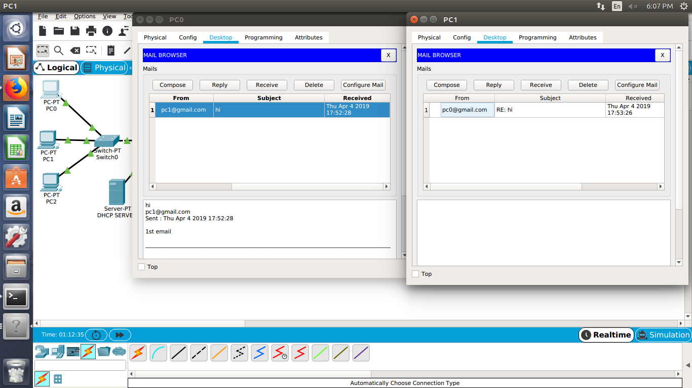

In PCs open the MAIL BROWSER in the Desktop and you can send/receive emails here.

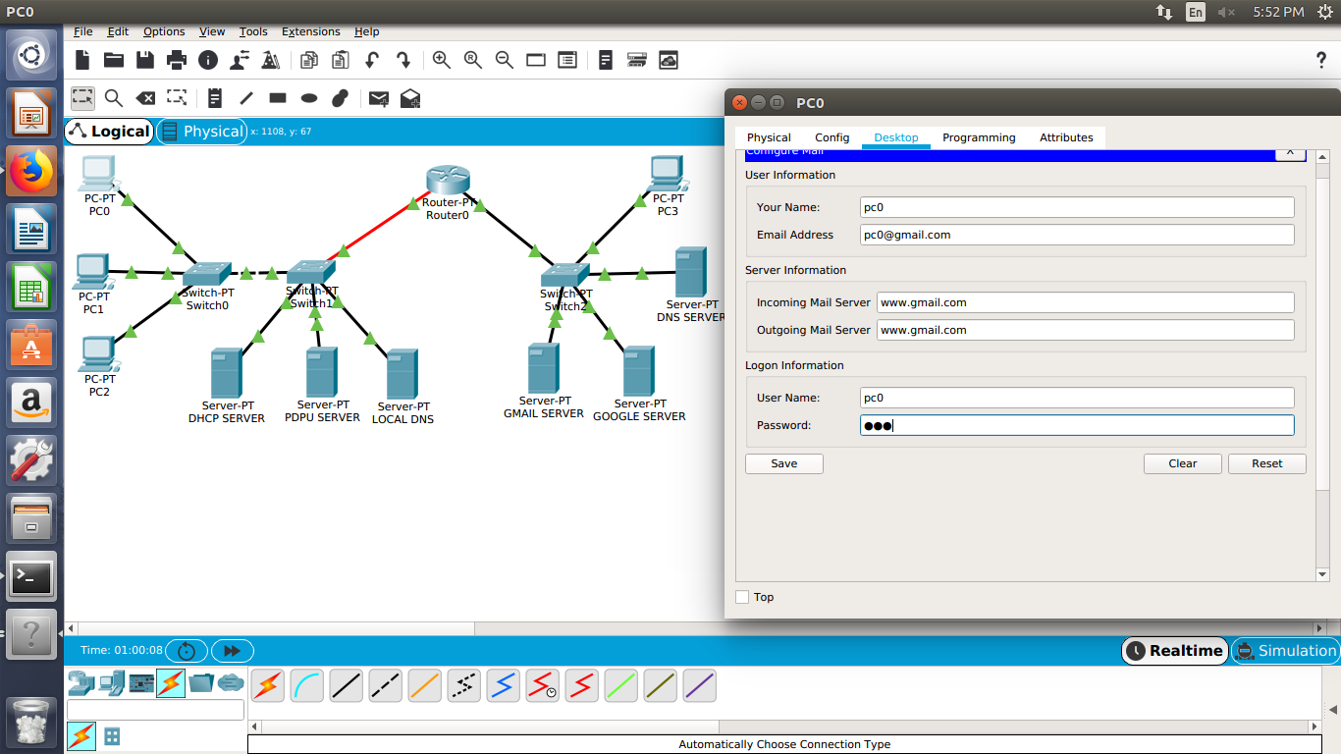

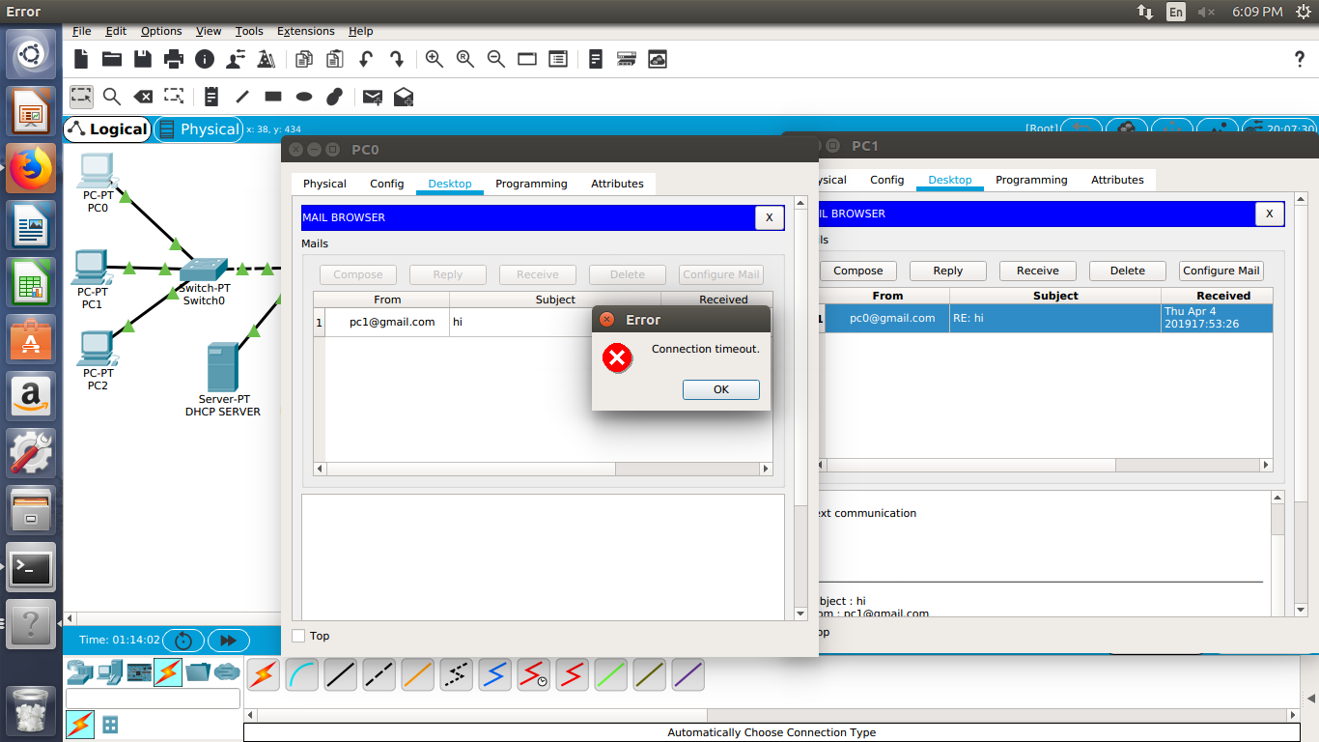

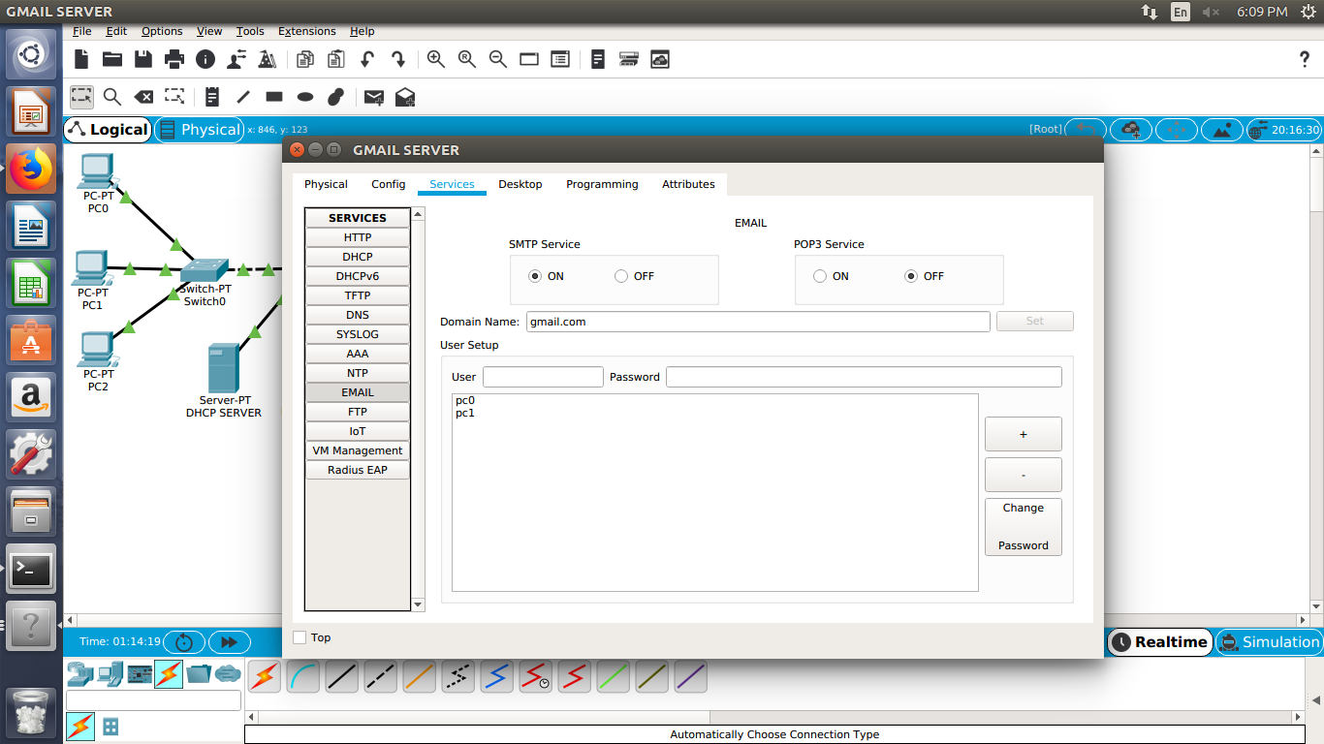

Set up the GMAIL server in the network 2 just like the setup of the HTTP server like done earlier.

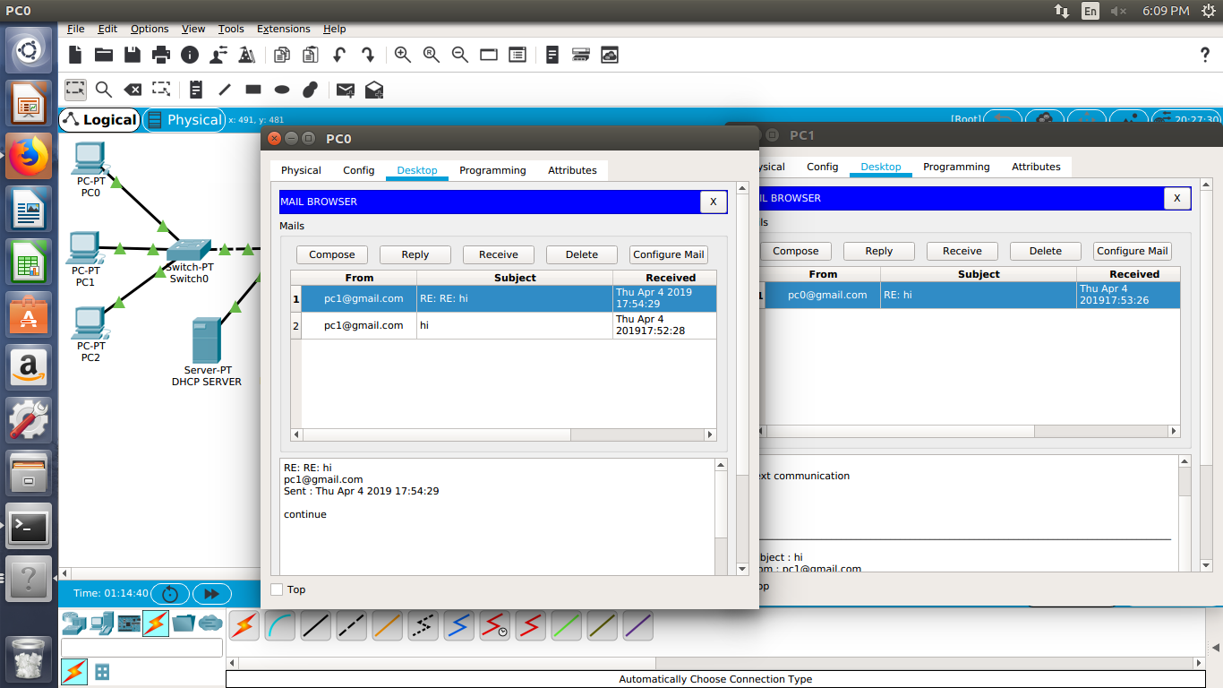

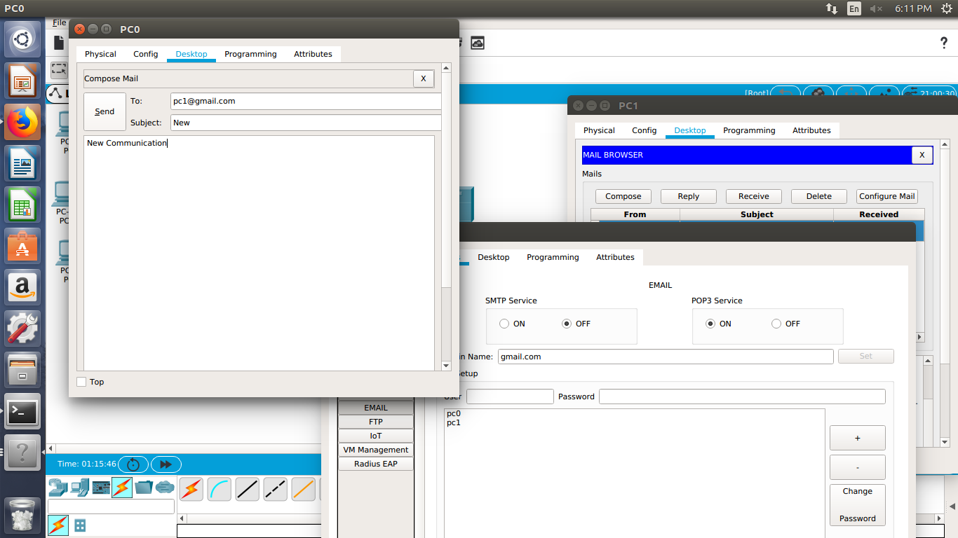

Emails are composed/received in the EMAIL BROWSER menu in the Desktop at the PCs.

Turn on the simulation after sending an email to observe the flow of packets in the Cisco Packet Tracer Network.

**EXPERIMENT: 6**

**AIM:** Implementation ofStop and Wait Protocol

**Stop-and-wait Protocol**, also referred to as [alternating bit protocol](https://en.wikipedia.org/wiki/Alternating_bit_protocol), is a method in [telecommunications](https://en.wikipedia.org/wiki/Telecommunications) to send information between two connected devices. It ensures that information is not lost due to dropped packets and that packets are received in the correct order. A stop-and-wait sender sends one [frame](https://en.wikipedia.org/wiki/Frame_(telecommunications)) at a time; it is a special case of the general [sliding window protocol](https://en.wikipedia.org/wiki/Sliding_window_protocol) with transmit and receive window sizes equal to one and greater than one respectively. After sending each frame, the sender doesn't send any further frames until it receives an [acknowledgement](https://en.wikipedia.org/wiki/Acknowledgement_(data_networks)) (ACK) signal. After receiving a valid frame, the receiver sends an ACK. If the ACK does not reach the sender before a certain time, known as the timeout, the sender sends the same frame again. The timeout countdown is reset after each frame transmission.

**PROCEDURE:**

* **Server Program**

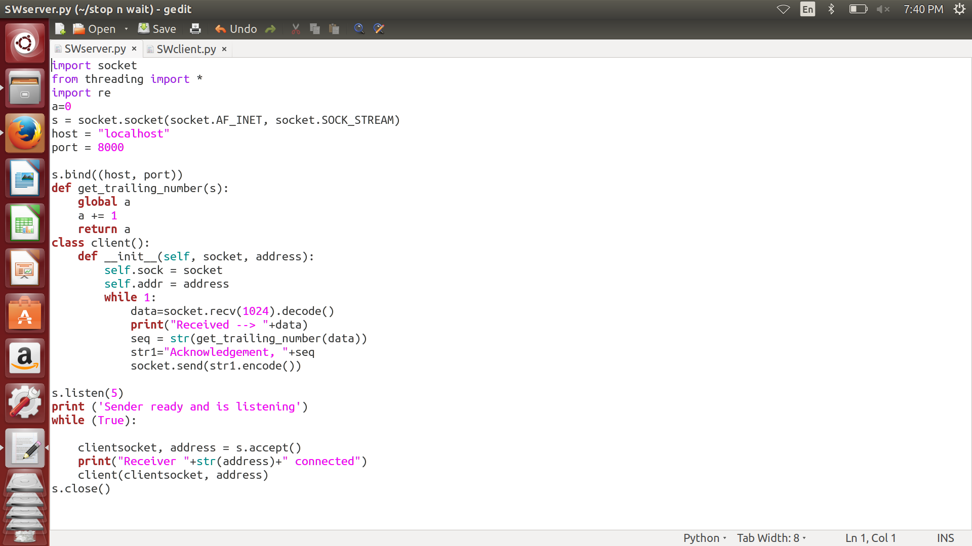

* **Client Program**

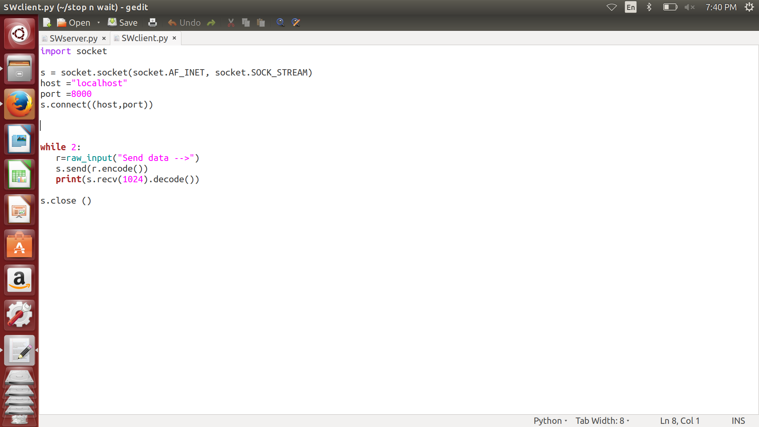

* **Interaction between Server and Client**

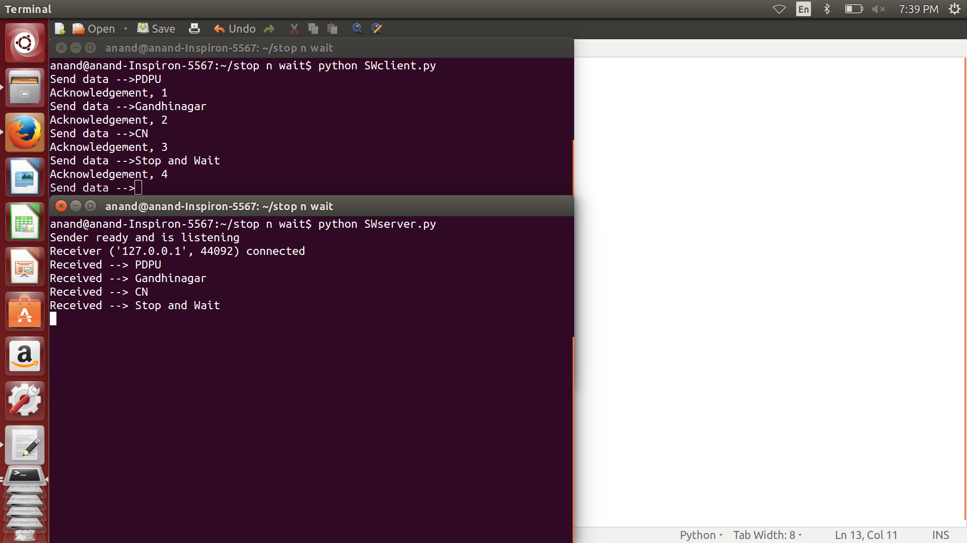

**EXPERIMENT: 7**

**AIM:** Implementation ofCRC

A **cyclic redundancy check** (**CRC**) is an [error-detecting code](https://en.wikipedia.org/wiki/Error_detection_and_correction) commonly used in digital [networks](https://en.wikipedia.org/wiki/Telecommunications_network) and storage devices to detect accidental changes to raw data. Blocks of data entering these systems get a short *check value* attached, based on the remainder of a [polynomial division](https://en.wikipedia.org/wiki/Polynomial_long_division) of their contents. On retrieval, the calculation is repeated and, in the event the check values do not match, corrective action can be taken against data corruption.

Specification of a CRC code requires definition of a so-called [generator polynomial](https://en.wikipedia.org/wiki/Generator_polynomial). This polynomial becomes the [divisor](https://en.wikipedia.org/wiki/Divisor) in a [polynomial long division](https://en.wikipedia.org/wiki/Polynomial_long_division), which takes the message as the [dividend](https://en.wikipedia.org/wiki/Division_(mathematics)) and in which the [quotient](https://en.wikipedia.org/wiki/Quotient) is discarded and the [remainder](https://en.wikipedia.org/wiki/Remainder) becomes the result. The important caveat is that the polynomial [coefficients](https://en.wikipedia.org/wiki/Coefficient) are calculated according to the arithmetic of a [finite field](https://en.wikipedia.org/wiki/Finite_field), so the addition operation can always be performed bitwise-parallel (there is no carry between digits).

**PROCEDURE:**

* **Server (Sender) Program**

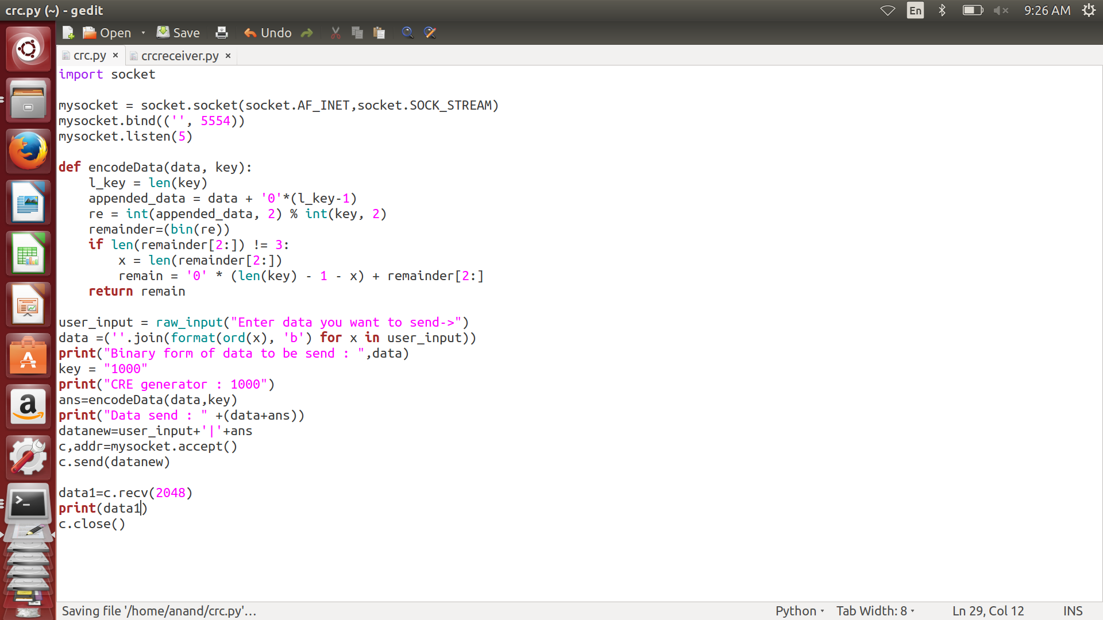

* **Client (Receiver) Program**

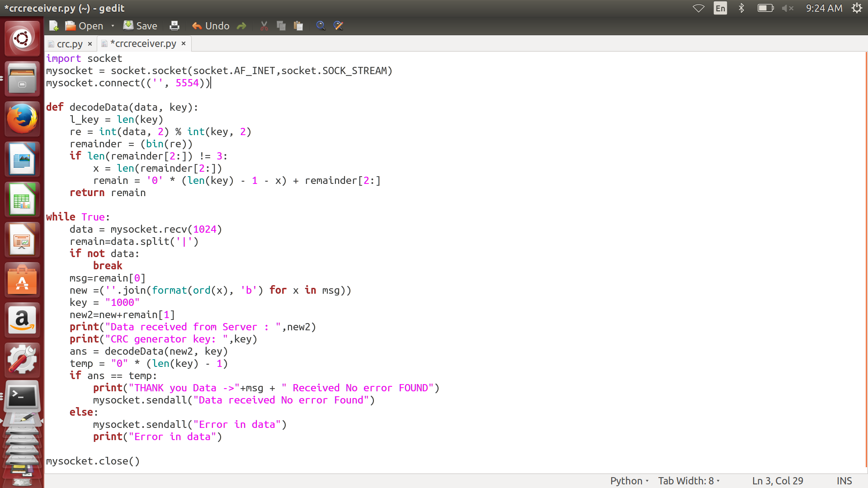

* **Interaction between Server and Client**

z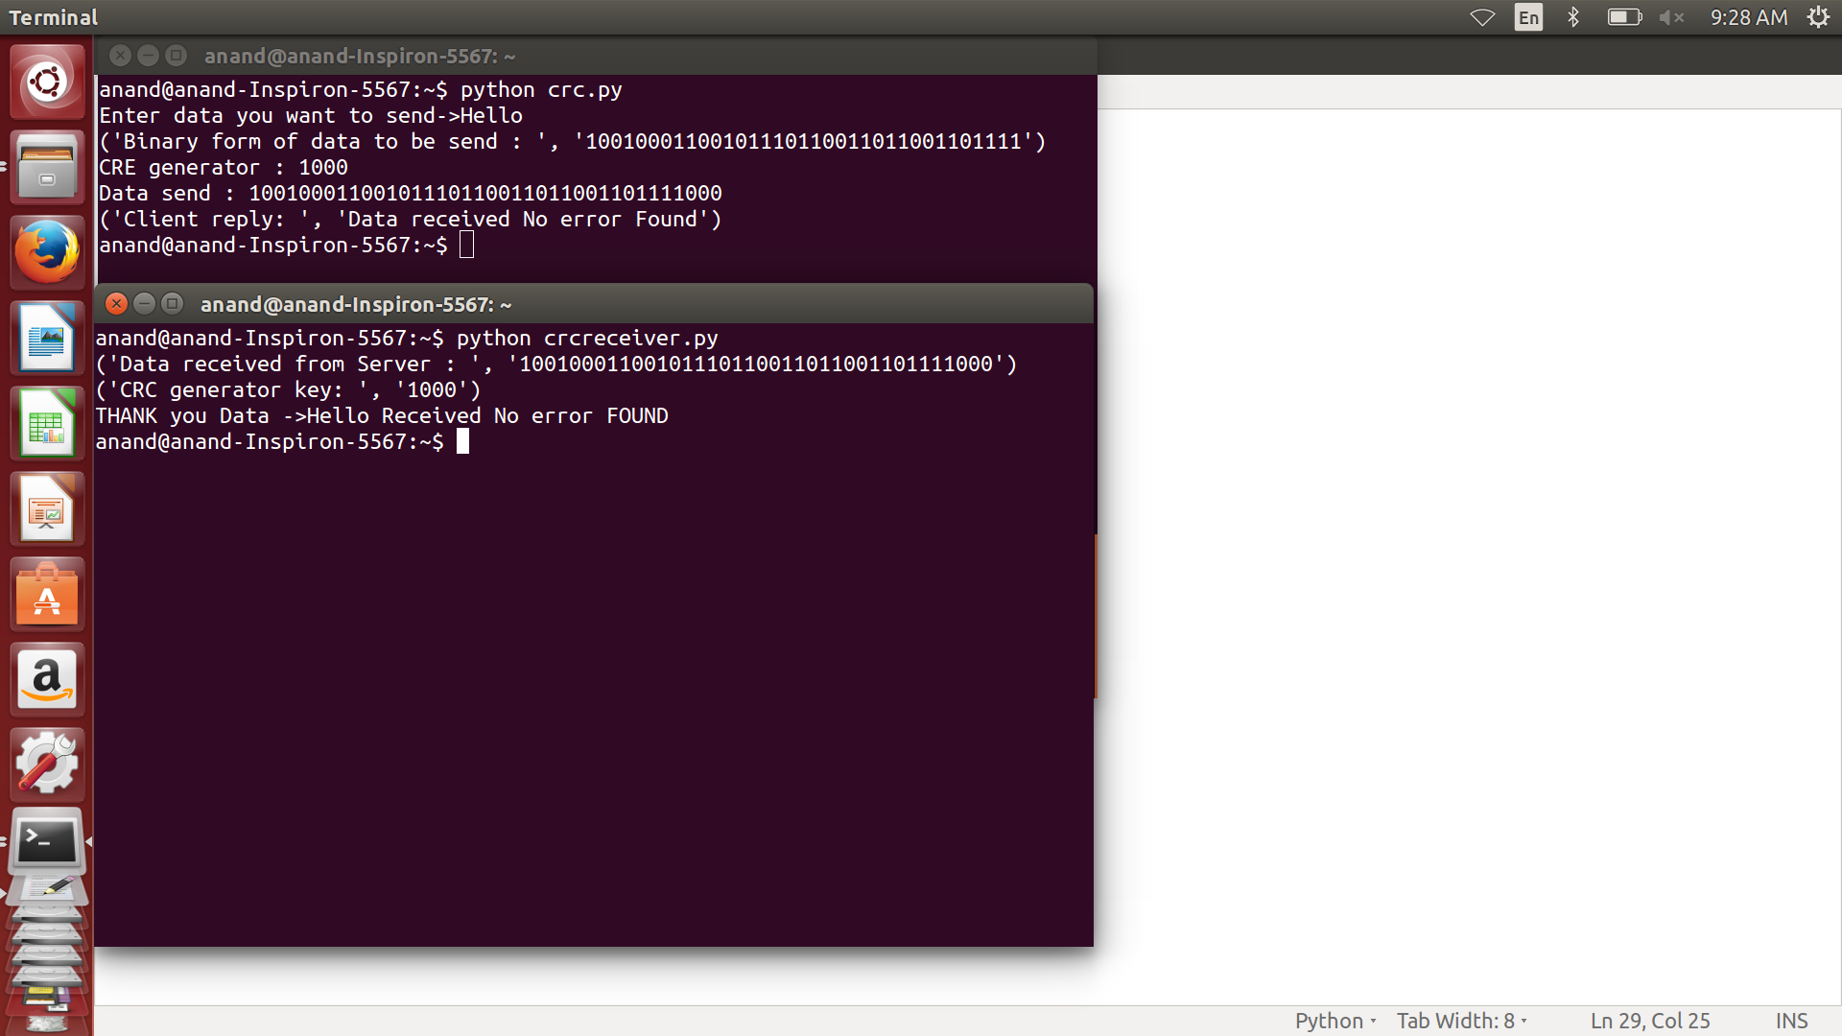

**EXPERIMENT: 8**

**AIM:** Implementation ofChecksum

A **checksum** is a small-sized [datum](https://en.wikipedia.org/wiki/Datum) derived from a block of [digital data](https://en.wikipedia.org/wiki/Digital_data) for the purpose of [detecting errors](https://en.wikipedia.org/wiki/Error_detection) that may have been introduced during its [transmission](https://en.wikipedia.org/wiki/Telecommunication) or [storage](https://en.wikipedia.org/wiki/Computer_storage). It is usually applied to an installation file after it is received from the download server. By themselves, checksums are often used to verify data integrity but are not relied upon to verify data [authenticity](https://en.wikipedia.org/wiki/Authentication).

A good checksum algorithm will usually output a significantly different value, even for small changes made to the input. This is especially true of [cryptographic hash functions](https://en.wikipedia.org/wiki/Cryptographic_hash_function), which may be used to detect many data corruption errors and verify overall [data integrity](https://en.wikipedia.org/wiki/Data_integrity); if the computed checksum for the current data input matches the stored value of a previously computed checksum, there is a very high probability the data has not been accidentally altered or corrupted.

**PROCEDURE:**

* **Server Program**

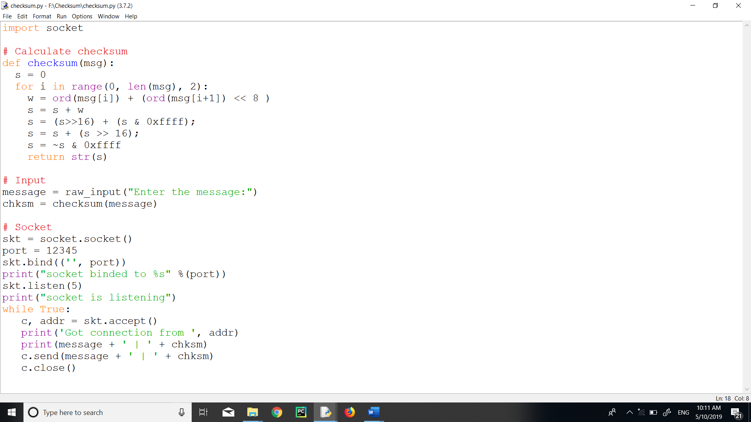

* **Client Program**

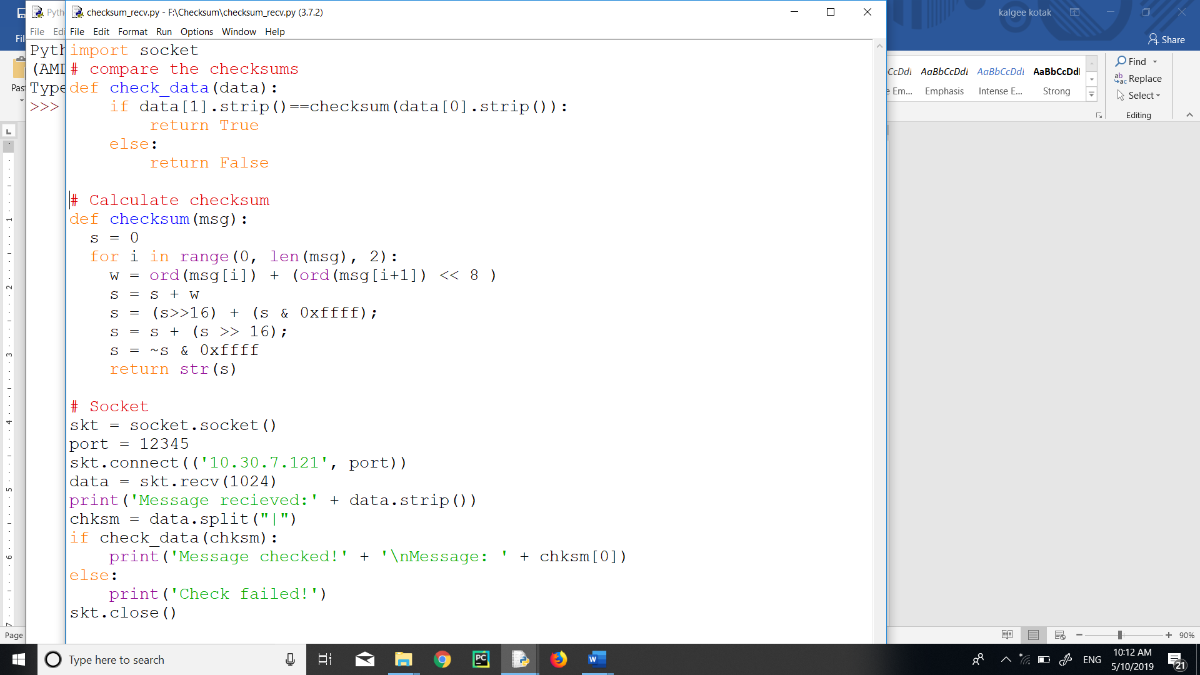

* **Interaction between Server and Client**

